## **Stack Overflow**

Stack Overflow is one of the world’s biggest technical questions answering site. It helps enthusiastic software developers solve their problems. Quora, Wikipedia, and YouTube are also user-generated content websites but finding the solution to a particular question might be time-consuming on those sites (Nir Eyal, 2014). On the other hand, Stack overflow solves these problems easily. Users can ask practical and detailed questions, as well as get the right answer without any distractions. The provided answers are specific, might be highly technical, and do not contain any discussion forum. Similarly, tagging questions with their subject areas makes it easier to find the interesting and right questions. It saves a programmer’s time while finding the solution to a problem but it will not be the same on other sites (Overflow, 2022). It contains 21+ million questions and helps 100 million people per month (Overflow, 2022). People spend so much time answering the questions of others on the site but what people get from it while using it, and what motivates them to continue using it are some interesting things to know about.

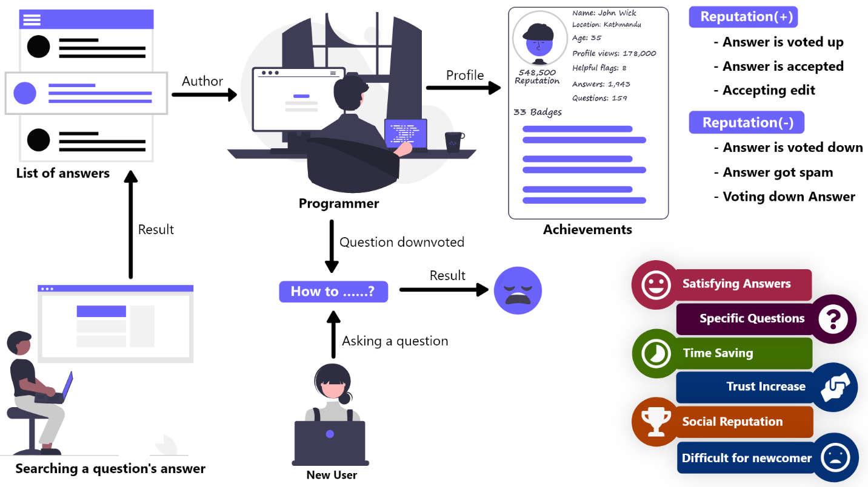

Figure 1: Stack overflow website

The site provides rewards to the ones who provide answers to the questions. In the same way, other users can respond to the answers and questions by giving an upvote or downvote and the most upvoted answers are infiltrated upwards. From these votes, the author of the answer also gets points and after reaching a certain point, the author earns badges which are satisfying and this makes them feel like they are at a special status and privilege. However, how many points and badges an author gets after responding to the questions is unclear and highly variable. On this site, points and badges are not just game mechanism but also represents how much a person has contributed to the community. It provides a platform for software engineers to enjoy helping other programmers and get the disserving respect as well as satisfaction from the community which is a game-like experience (Nir Eyal, 2014).

A user can gain or lose reputation points according to the response of other users to that user’s work. When a question, answer, or article is voted up or an answer is marked as accepted or accepting a suggested edit, reputation points are gained. However, there is a limitation on the reputation points gained per day from up and downvotes and suggested edits. Conversely, reputation point is loosed if the question, answer, or article is voted down or on voting down the answer, article of other users, or if a post has 6 spam flags. The starting reputation point for all the users is one and never gets down below it. Reputation points cannot be increased by accepting own answer but there is no effect on the reputation points on deleting a post. Reversing a vote will also reverse the reputation point that was gained or loosed (Overflow, 2022). Users can achieve three levels of badges which are bronze, silver, and gold. Badges can be also earned by just reading the page too (Overflow, 2022).

New users find it difficult to participate in the stack overflow community since they are overwhelmed with down and close votes. Their questions must also go through a "First Post" review queue; otherwise, the questions will not be visible to the public. However, the most typical cause for a downvote is that expert programmers believe the question is too simple. It will be good for newcomers if the programmers ignore rather than downvote the questions. If the question box is redesigned with a paginated workflow, new users will be more likely to fill out all of the essential information. Many users do not receive the assistance they desire since their queries are not answered due to the lack of a method for retrieving and re-posting prior questions. Similarly, many inquiries on the web have no upvoted or acceptable replies (Gaiser, 2020).

The reputation system has played a big role in the success of the Stack Overflow website. If there was no reputation system on the website, then it would be boring and worthless answering the questions because the contribution of a user could not be evaluated which is dissatisfaction. And because of this, there would be fewer users answering the questions. Likewise, users would have a difficult time finding the right and satisfying answer. Due to this, the site would not have as many users as it has at the current moment. This proves that introducing gamification in a system provides a better as well as more satisfying user experience.

## **PUBG Mobile**

PUBG Mobile is a very popular game on the mobile platform. It has highly gamified content which gives a better and highly satisfying user experience than the normal mobile games due to which gamers are addicted to it. In 2020, it has generated $2.6 billion in revenue and become the world’s highest-grossing game (Curry, 2022). It is a free-to-play battle royal game. A battle royal game is a multiplayer game involving a large number of players who control their character and parachute onto a virtual map with a shrinking zone where they will have to collect loots, fight with each other and survive until only one person is left (Staff, 2022). But it has more interesting content like ranking system, Points and Coupons, inventory management, royal pass, create opening, events, banning system, new UI, and updates compared to a normal battle royal game. Similarly, it has a realistic gaming environment. The guns, areas, and fight mechanisms match with the real world. In the same way, some of its features like shooting mechanics, character movements, map variety, vehicle variety, match mode variety, and entertaining looting alternative to fighting make it unique and better than other battle royal games (Haley, 2021).

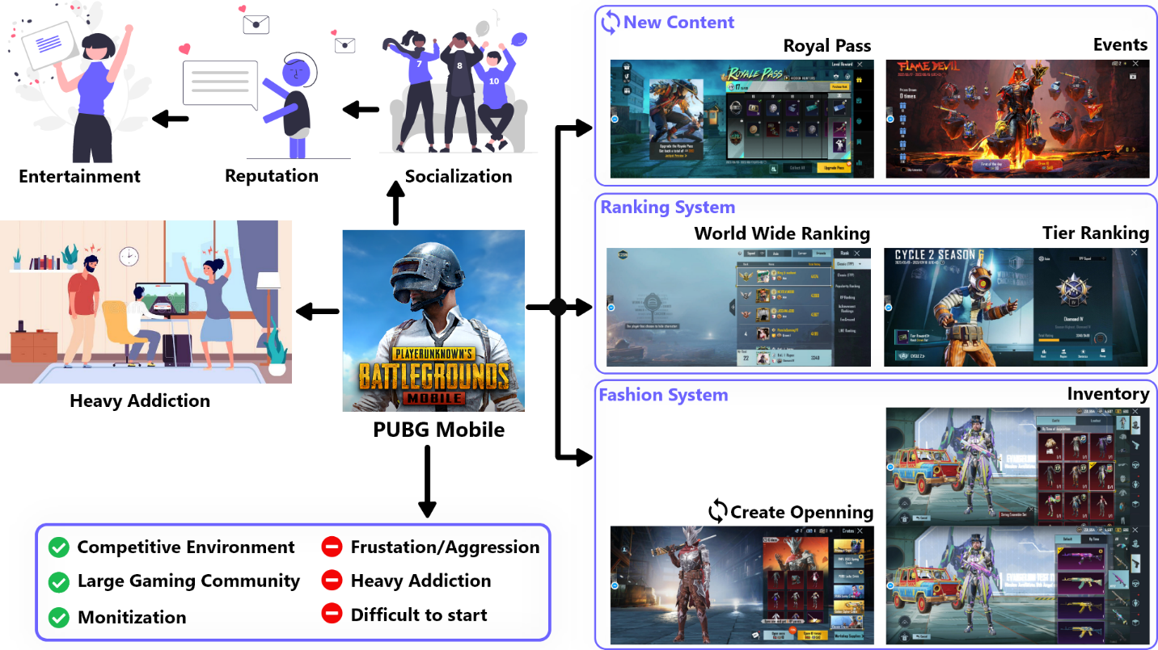

Figure 2: PUBG Mobile

Players can earn and lose points from battle royal matches and these points are used to rank up the player’s tier (badge). Bronze, Silver, Gold, Platinum, Diamond, Crown, Ace, Ace Master, Ace Dominator, and conqueror are the tier levels from lower to higher (Rai, 2022). Earning points from matches becomes harder after reaching a higher tier or players can lose points if they don’t perform well. However, players’ tier is reset to a lower level after each season and they have to again level up it. Players can look at their match history, the performance status of each match, and each season's total kills, KD (Kill/Death Ratio), surviving time, the number of matches played, or current rank among friends and worldwide based on Achievement Points, KD, Surviving Time, Popularity Points, Royal Pass points. Likewise, unlocking the achievements can give achievement points, equipment ‘s skins, and emotes along with BP, Silver, AG coins, and coupons which are used to purchase items in the shop. Spending UC on events, players might also get some or all UC back. UC is the most expensive and valuable currency in the game which is also used to purchase items in the shop. On the other hand, players can add friends and play a match in solo or dual, or squad mode too. Different maps and various types of match modes give players flexibility and different flavors of gaming experience. Players can visit others' profiles and check out their skill, season status, inventory, and achievements, send gifts and popularity points, as well as play a custom match with them.

Inventory is one of the most attractive parts of the game. Players can view their cloth, gun, vehicle, helmet, bags, parachute skins, emotes, stickers, coupons, redeem points, and redeem cards. Similarly, they can get skins, coupons, and emotes by spending UC, Silver Points, AG Points, and BP Points from the shop or by redeeming them in the events. They can play matching wearing any cloth skins, applying any gun and vehicle skins. They can open creates with UC but money is required to buy UC. The most common creates are premium, classic, supply, and soldier creates. On the other hand, these crates can be opened without UC too but it requires coupons, AG, or BP currency. Likewise, Players can get new guns, vehicles, clothes skins, emotes, coupons, Silver, AG, BP currency, stickers, etc. after opening creates. These things can be achieved from events too after completing the event missions. They can earn titles, avatar frames, and equipment skins from events and achievements. Some of them are unique and rare. In the same way, the game also offers upgradable skin of guns, clothes, and vehicles but they have to spend lots of UC to fully upgrade them. These skins are very attractive and only rich players have these skins. They can show up their inventory items in the lobby as well as inside the match. Inventory can be regarded as the fashion system.

New updates are provided time-to-time so that the players can have a new and exciting gaming experience and they won’t get bored. Nowadays, New seasons are launched every two months and an application update before each season. Players can experience new features and UI design after each application update. Similarly, new seasons bring new events inside the matches so that players can explore new areas. A new Royal Pass is also launched every month which contains cloth, guns, vehicle skins, emotes, coupons, silver points, BP points, AG points, stickers, popularities points, etc. Each Royal Pass contains a free and elite version of it. On the other hand, players get limited and low-quality items in the free version,. However, they can also spend UC to get an elite royal pass that contains high-quality items. They can report other players or teammates who break the rules like cheating, use of vulgar language, and killing teammates. The reported players can get banned from the game for a certain time or lifetime according to their actions. This makes gameplay very fair and all players want this. Some guidance and free gear are also provided to the newly joined players so that they can taste the game more easily and quickly involved in its gaming community.

Pushing rank is very difficult and frustrating. Players have to give lots of dedication and time to be listed as one of the number one players but it will give the player just an online reputation only. PUBG mobile is difficult to play and requires high skill to get the full fun in the matches. Moreover, the recoil system of the guns and too many buttons to control the character make the gameplay difficult for beginners. In the same way, new players are eaten by the well-skilled players in the matches and most of them quit playing the game because of this. Matching low-skilled players with other low-skilled players would be better for beginners. Sometimes new updates also bring bugs and glitches which make the gaming experience bad. Some gamers become heavily addicted to this game. Due to this, players suffer from physical and mental health issues, sleeping disorders, violent languages, aggressive behavior, poor academic performance, social distancing, and anxiety (JUSTZAYNED, 2021). Similarly, players also start spending money on Royal Passes, create openings, and other fancy things.

Players who have lots of items in inventory, high-quality gears, Royal Pass, and high skill are regarded as “pro” players, get respect, and hold high-level status in the PUBG mobile gaming community. Those who don’t have these things are regarded as “bot” players or beginners. Some of the players spend more time on opening creates, participating in events, and purchasing Royal Pass to have a high level of inventory rather than playing matches. PUBG Mobile provides an intense and competitive gaming environment with a ranking and fashion system among gamers. The introduction of new content brings excitement among players so that players never will be bored playing.

## **Nike Run Club**

Most people who love exercise and training can not continue the training for a long time due to a lack of motivation. People get bored having consistent training or even fail to start without any form of encouragement or a personal trainer or a running partner because they don’t get any enjoyment. This kind of motivation gap is overcome by the Nike Run Club app by encouraging the people in many different ways with the help of a gamified approach. This app features custom coaching plans, GPS, tracking, guided running workouts, motivation from other users and friends, and celebrating progress with congratulation messages and achievement titles which are fun to do. In the same way, users are also continually encouraged to report their runs and participate in organized challenges with other runners using the app. Many of the challenges are presented as colorful full-screen modals with awards for those who complete them. However, each challenge is only available for a limited period, giving hesitant users an added push to commit.

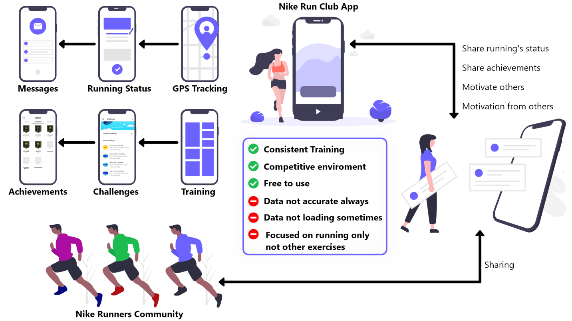

Figure 3: Nike Run Club

Keeping users motivated after the initial enthusiasm for a new app wears off can be difficult. But celebrating accomplishments is a great approach to keep users engaged throughout and after their first onboarding. Nike frequently recognizes modest victories by sending tailored messages praising users on their achievements and urging them to keep on moving. The constant encouragement increases users' confidence in their abilities while simultaneously increasing app engagement. And with each run, you'll unlock new achievements that you can share with your friends and improve over time. Likewise, users can also share their achievements with their friends instantly. A retention hook is a built-in feature that gives users a cause to send notifications to other users, which encourages them to return to the app. Of course, Nike doesn't generate money by making free apps. They make money by selling shoes and other athletic gear. As a result, the app includes an upsell prompt for Nike running items, which integrates online purchasing directly into the program and regularly tempts users to buy additional Nike products. The user's profile and running style are used to personalize product recommendations. Users can even track miles on their existing pairs of running shoes and receive automatic reminders when it's time to replace them.

But this app also has challenges like the provided data of the running is not always accurate, sometimes runs do not sync, do not provide any difficulty level indication of each run, and facing disruptive glitches (Jones, 2021). Similarly, GPS accuracy gets extremely poor and sometimes the challenges become very hard to complete like 100 miles a day (Harry, 2022). The app is not provided in all countries and will not work properly. However, people from all around the world who love to run and want to try this app but could not be able to take advantage of it. It has training plans and coaching for running only but does not focus on other exercises related to yoga and gym otherwise people who love to do yoga or gym rather than running would also use it.

One of the app's value propositions is to improve and maintain motivation, which Nike achieves with time-limited and well-organized challenges, as well as by consistently recognizing users' accomplishments. Power users may purchase Nike fitness gear directly from the app due to integrated e-commerce features. Retention hooks motivate lazy users to come back to the app while also boosting the motivation of active users. This app makes people who are lazy or don’t have any encouragement to be a better version of themselves with the help of gamified content (ReallyGoodUX, 2022). Similarly, the app allows any runners the opportunity to join its community of runners, analyze personal running statics, participate in the personalized program for training according to personal objectives and level, share race statics with other users and friends, and win badges and trophies by participating in challenges. All of these are gamified features for the users to have a competitive and entertaining mechanism. The goal of this app is not just to bring users’ interests toward the Nike brand but also to spread and improve the Nike brand’s image in the sports community (Leclercq, 2015).